Power BI – Module End Evaluation

Name: Haritha Hari
Batch: 69

Q1: Data Cleaning and Loading
- Import the dataset into Power BI using Power Query Editor.
In power BI open the excel through Get data in Home tab, then select the data from the downloads. After the data loaded Click on Transform data on Home tab, Then the data will be open in a new window called power query editor. In power Query editor we can perform various tasks such as Removing duplicate data and can handle the missing values.
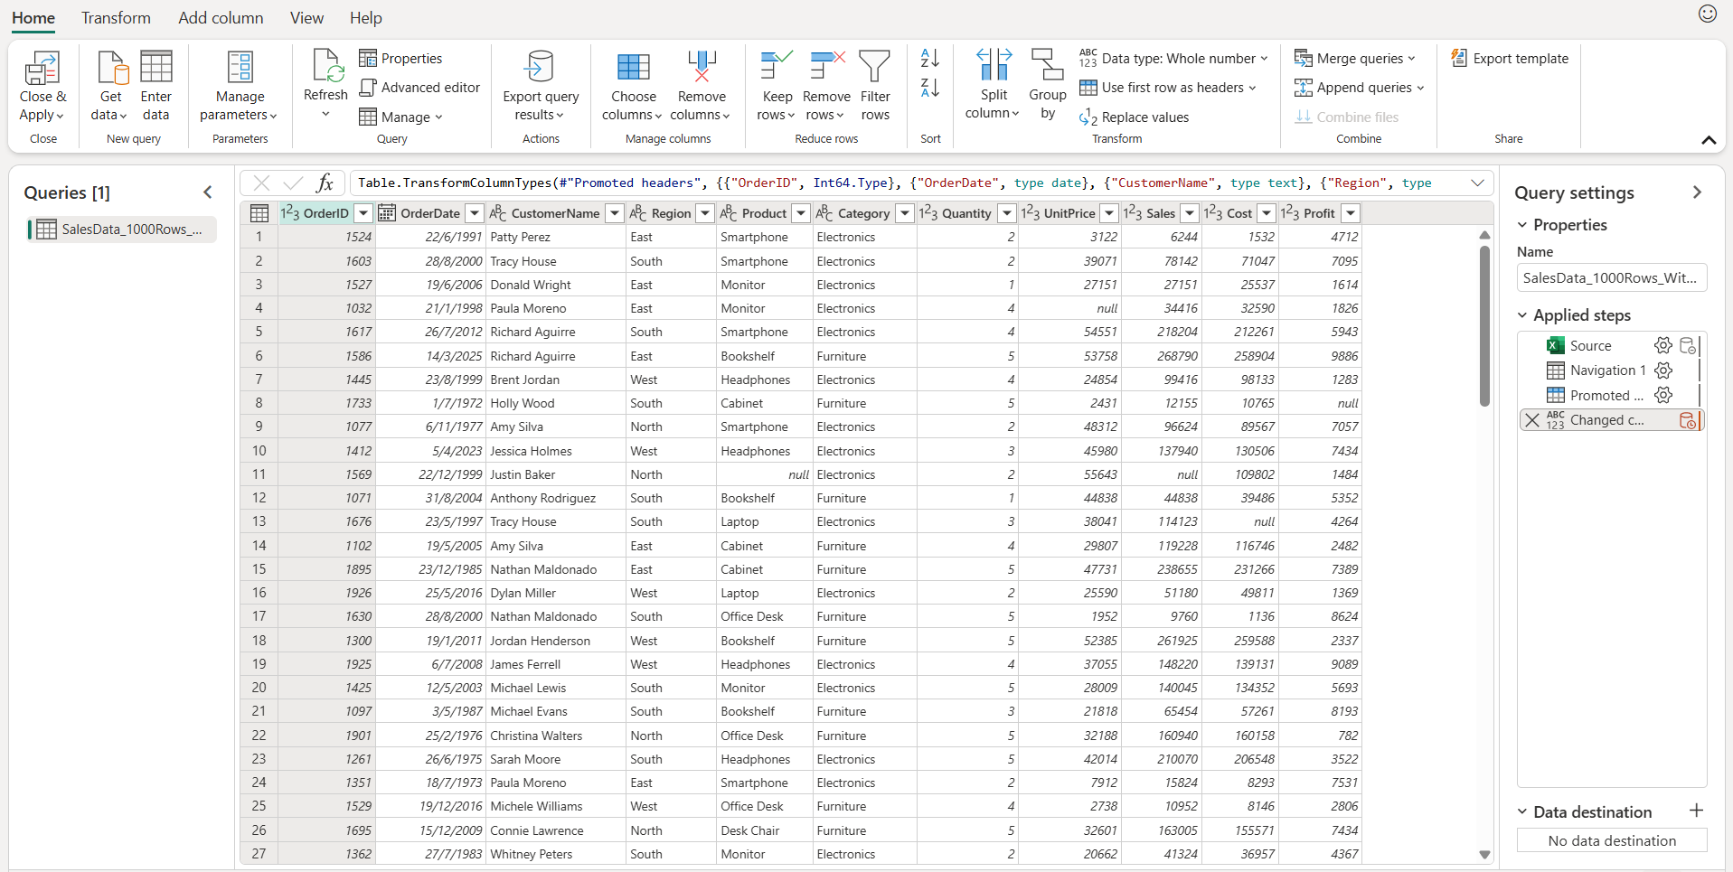

- Perform the necessary data cleaning steps to prepare it for analysis

- Handling missing values in columns
To handle the missing data we can select the particular column or columns then right click, there will be an option Replace value , there will be two cells one is value to find and another is Replace with, both of these options will come under Basic
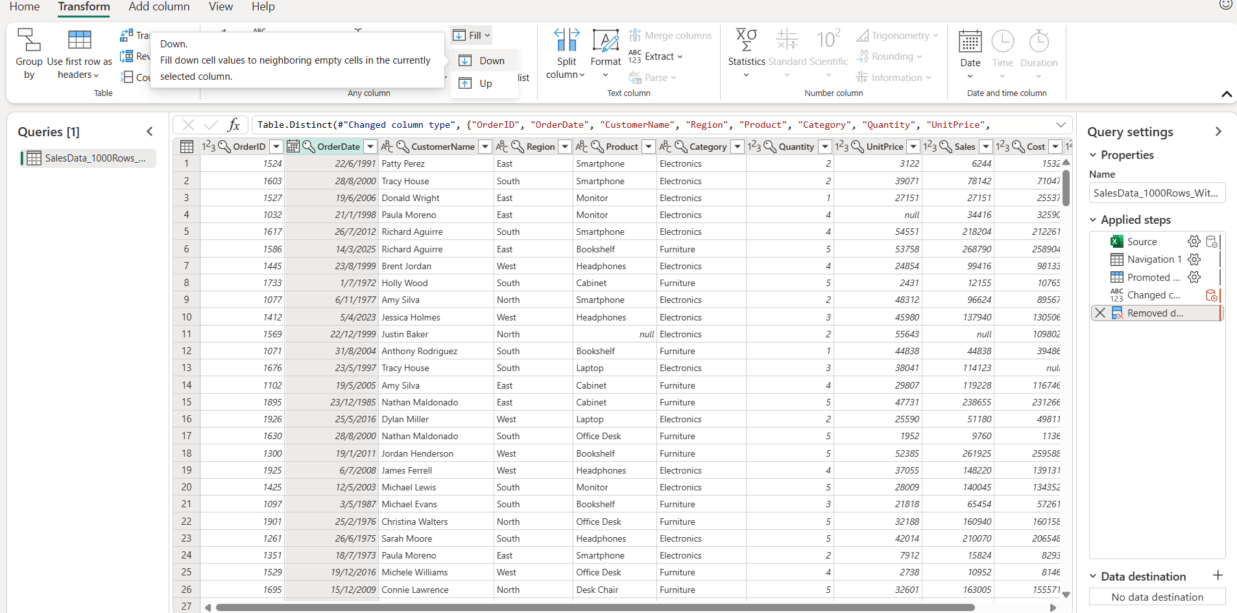

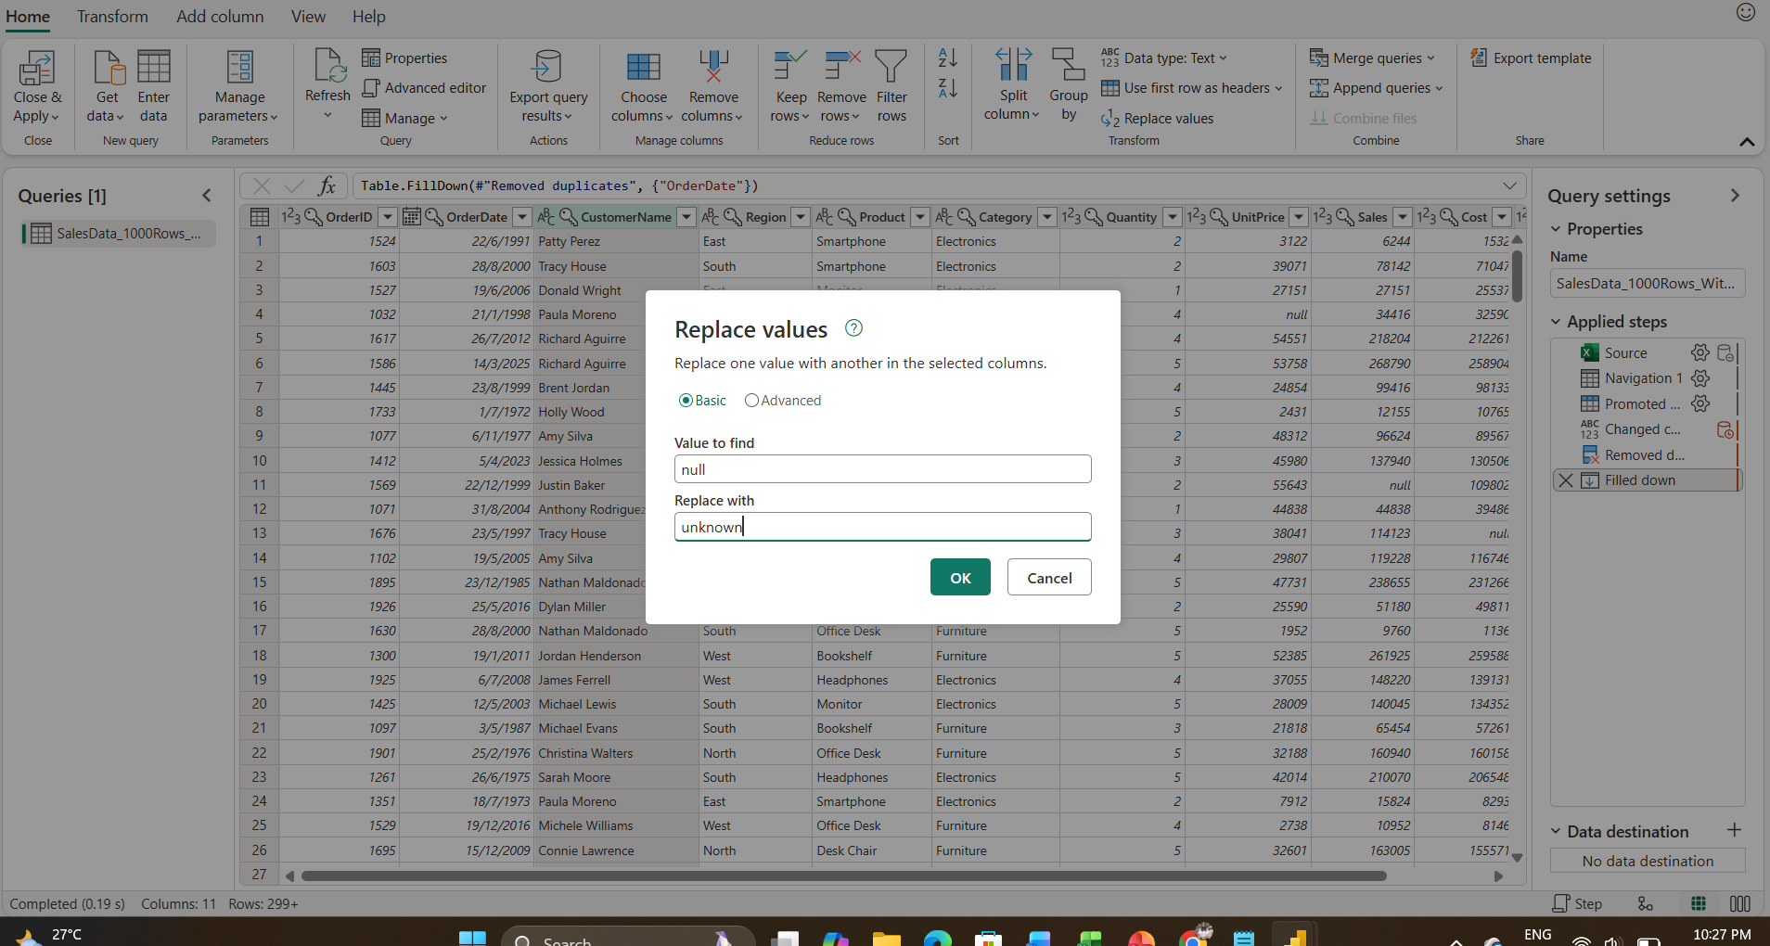

For the Unite price column some of the cells are missing, To find the missing values we can create a new column named “New Unit price”, this can be identified by divide the sales by quantity and also create a new column named “New sales” to find the missing values in Sales column , it can be found by multiplying quantity by unit price.
Similarly profit column is the difference of sales and cost, so that a new column “New profit” can be create by subtracting cost from sales, Like that ‘New cost” can be created by subtracting profit from sales

- Removing duplicate rows
To remove the duplicate rows, select the entire data and go to home tab then remove rows and click on remove duplicates.
This will delete the duplicate rows.

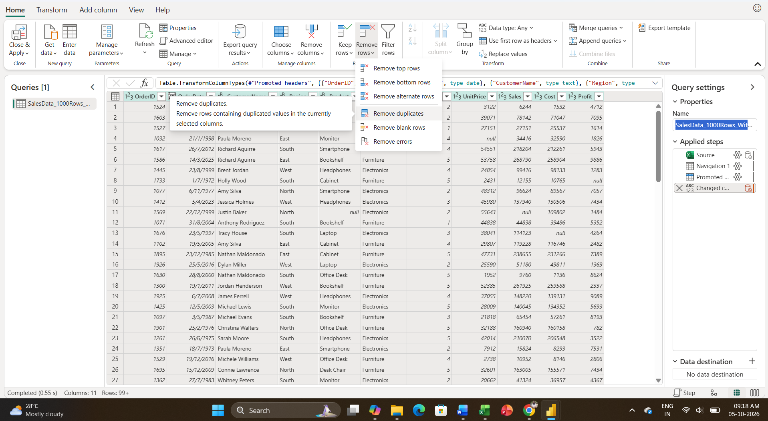

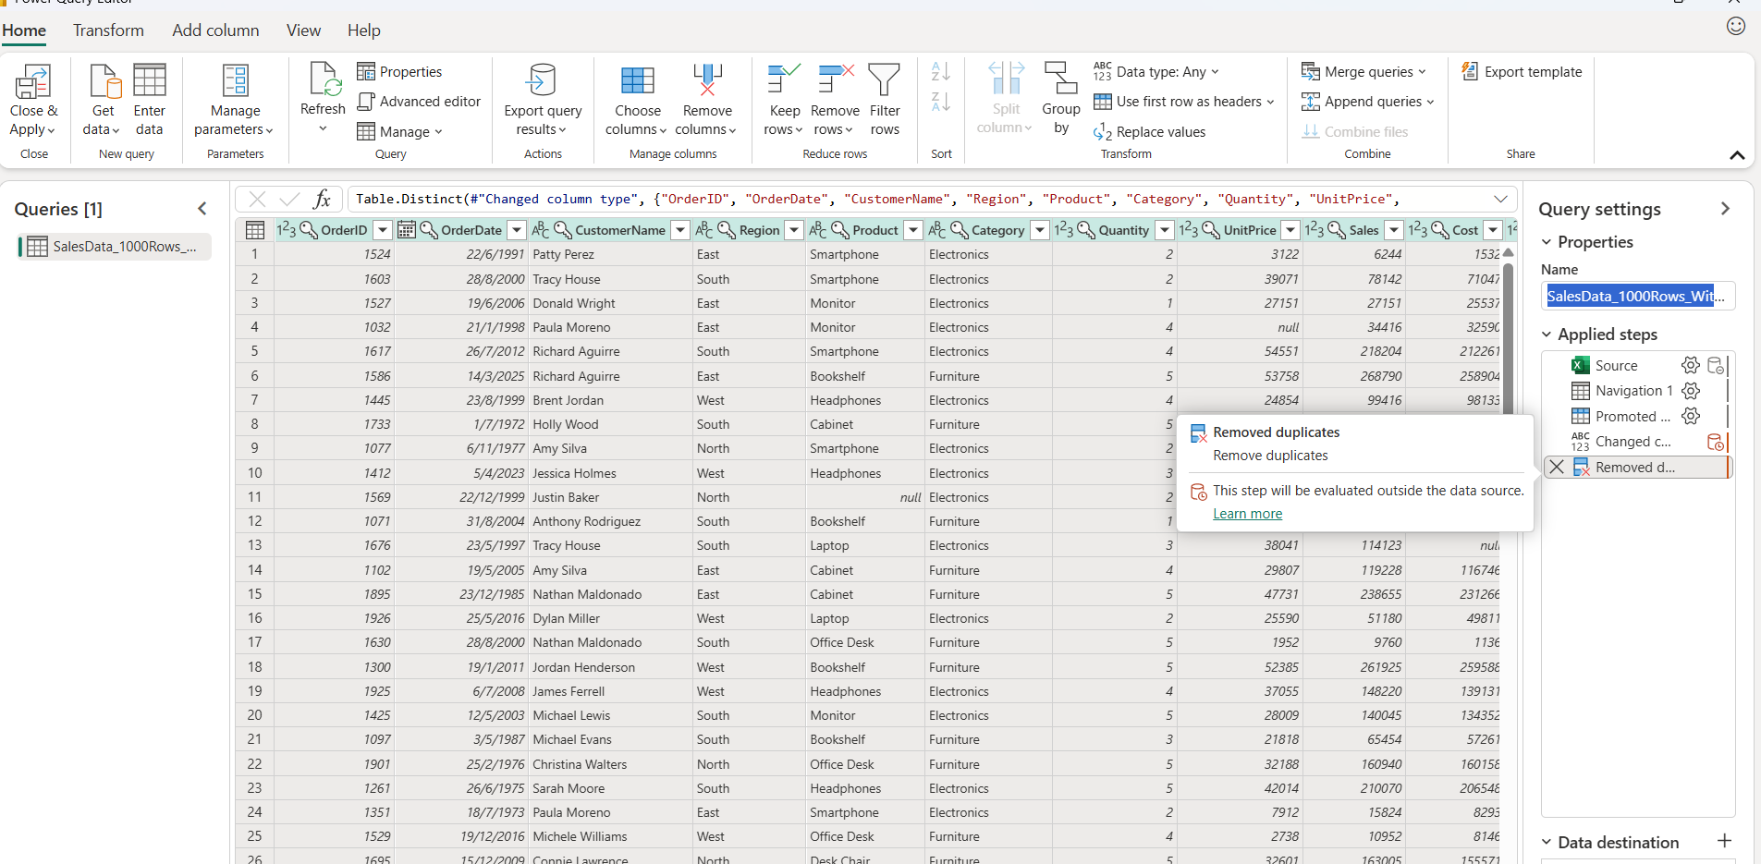
Applied steps such as remove duplicate will appear on Query settings on right side.

